How to set up a Je-S Account
This user guide will help you to set up a Je-S account to apply for research council funding as either a Principle Investigator or Co-Investigator. If you are working on a grant with overseas investigators they will also need to follow this process to set up a Je-S account.
Je-S can be accessed from https://je-s.rcuk.ac.uk/JeS2WebLoginSite/Login.aspx

Step 1: Go to the Je-S home page and select Create an Account on the left hand side
Accept the terms and conditions at the bottom of the next page.
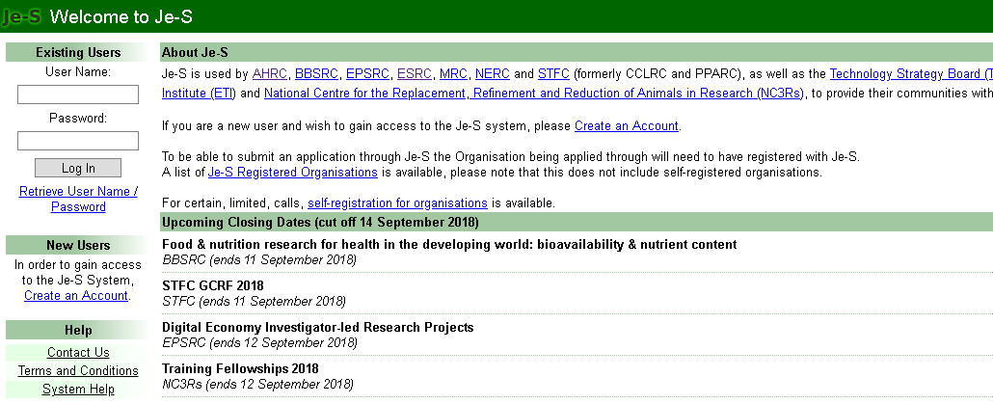

Step 2: Check if you have an existing account
You may already have a Je-S account from a previous institution that needs updating. Check if this is the case by entering your e-mail address or ORCID number.
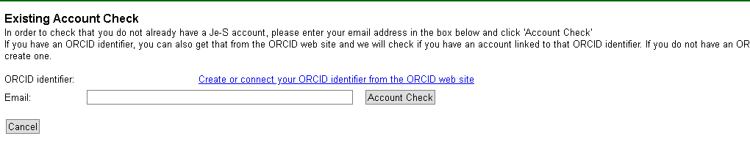

Step 3: Choose account type
If you are setting up an account in order to apply for grants select An Applicant on a Standard or Outline Proposal (Principal/Co/Researcher Co-Investigator).
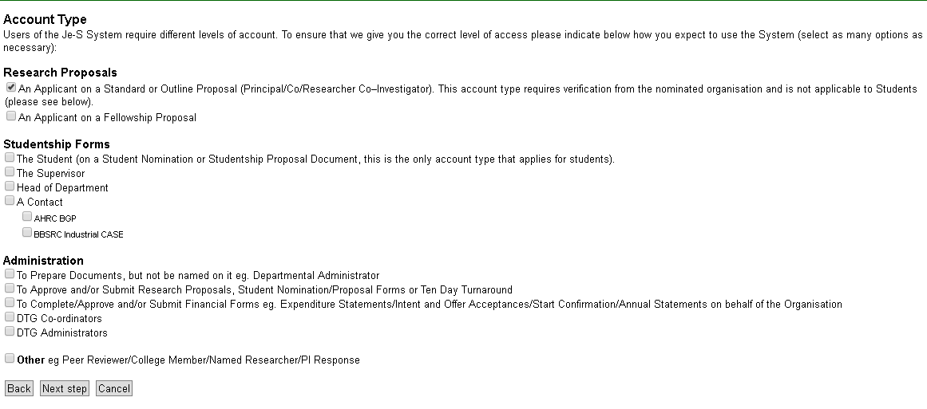

Step 4: Fill in your personal details
The next page will ask for you qualifications – this is an optional field.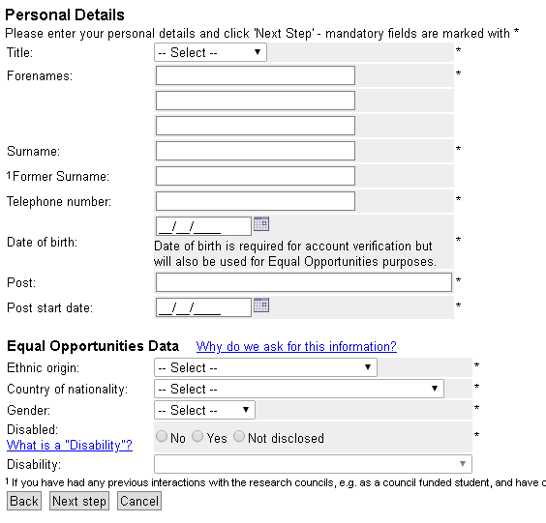

Step 5: Add in organisation and department
These can be selected in the relevant pop out search windows. For overseas researchers whose organisations can’t be found on Je-S they will need to contact the Je-S Help Desk on +44 (0) 1793 444 164.

Step 6: Choose username and password

Step 7: Confirm account details
Check your account details are correct and click Create Account.
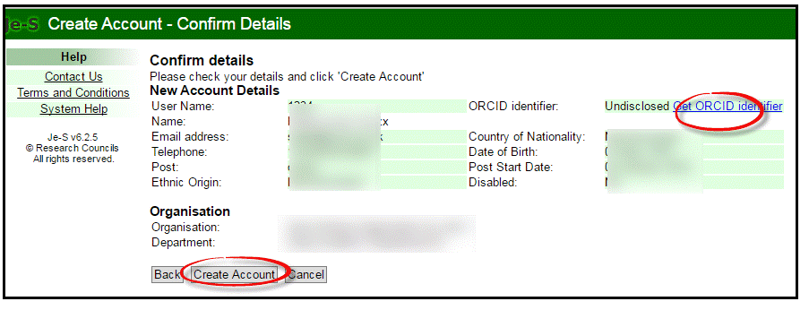
You will then receive an e-mail with a link which you must click on to activate your account. If you are setting the account as an Applicant the account will need to be verified by your nominated institution. Until this is done you will be able to use Je-S but not submit any proposals. You will receive an e-mail to confirm when your account has been validated.

