How to Create and Link an ORCID iD using Researchfish
An ORCID identifier is a unique 16 character identifier that can be used to clearly identify you and the outputs of your research. Having an ORCID ensures that your publications and citations are credited only to you and not someone with a similar name. It can also bring together publications across a range of bibliographic databases such as Scopus, PubMED or Web of Science and reference them in one place.
Having an ORCID will simplify the process of adding publications to your awards in Researchfish as it draws across data from your ORCID profile. This user guide shows you how to set up an ORCID account from Researchfish and how to draw through your publications listed in ORCID.
Step 1: Access the ORCID website
You can create an ORCID iD from your Researchfish home page if you do not already have one. Click on the Connect to ORCID button in the top right hand corner to take you to the ORCID website.
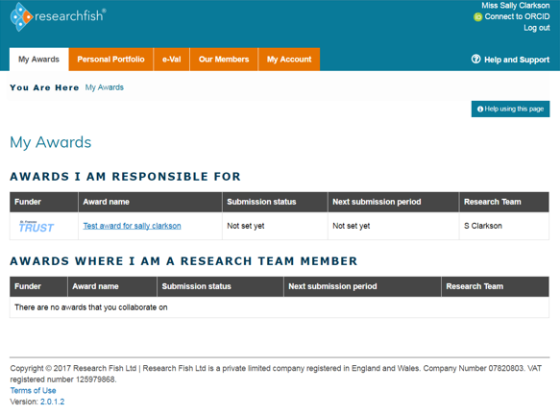

Step 2: Complete the ORCID registration form
Fill in the ORCID registration form with your name and e-mail address and select a password. Make sure the box Allow this permission until I revoke it at the top is ticked and the green Public button at the bottom is selected. This ensures that Researchfish pulls across all publications listed under your ORCID account. Then click to submit the form.
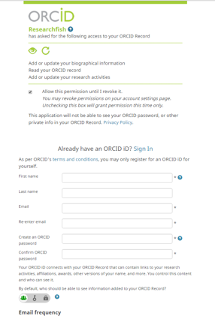
You will then be taken back to your Researchfish page where you will see your unique ORCID identifier. You will receive an email from ORCID confirming your ORCID iD and asking you to verify the account.
If you already have an ORCID account, complete Step 1 above to connect it to your Researchfish account and follow the on-screen instructions.
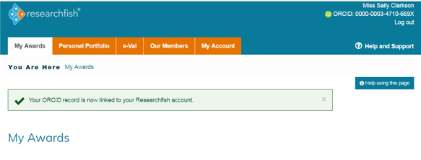

Step 3: Linking publications between ORCID and Researchfish
Once you have an ORCID account you can link it to all your existing publications from a variety of sources. Please see the following LibGuide for more information on how to use and build up your ORCID portfolio: http://libguides.reading.ac.uk/orcid/home. There are also some handouts available in the LibGuide that take you through each step (see Sign up for ORCID and Grow your ORCID).
When you have your publications listed in your ORCID profile, these can be drawn through to populate the Publications area of Researchfish. To do this, go to either your Personal Profile or My Awards. Click on the Publications heading under Common Outcomes.
You will see the following screen:
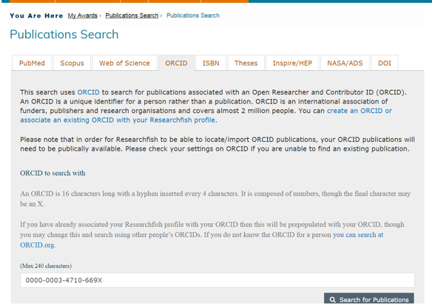

Select the ORCID tab and you will see your unique ORCID identifier in the text box. Click on the Search for Publications box and all your publications from ORCID will be drawn through as shown below:
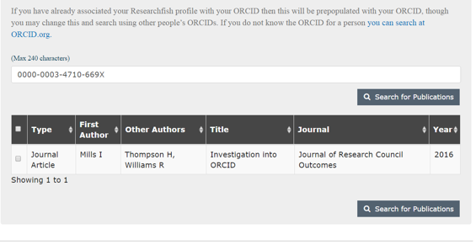
From here you can link publications to the relevant award(s) by selecting them under the Associate Outcomes with Awards heading:

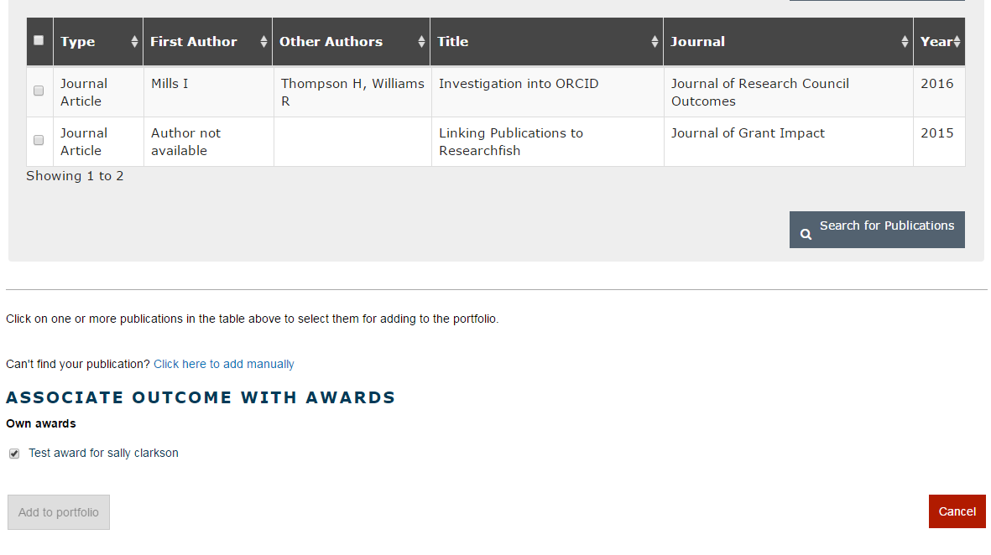

Step 4: Updating publications in Researchfish via ORCID
Any publications you add to ORCID throughout the year can be drawn through to your Researchfish portfolio. To do this repeat Step 3 up to clicking the Search for Publications button. Once you have clicked this button, the updated list of publications will be displayed and you can proceed to attribute these to your awards as you wish.

